**Racing Bar Plot Documentation**

**Step 1 -** Installing **bar-chart-race** module. You can do it inside Jupyter Notebook as shown below:

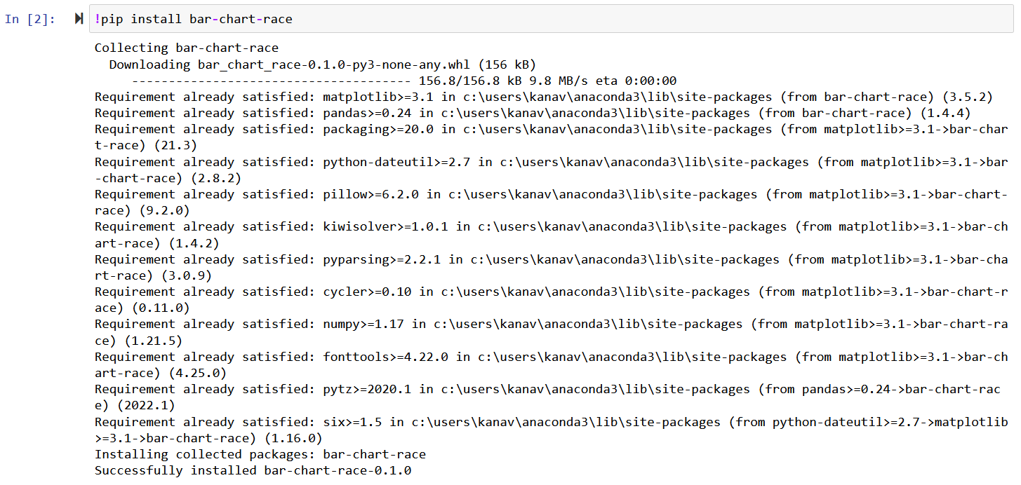

**Step 2 -** Import required library - **bar_chart_race**



**Step 3 -** Call bar_chart_race function with following parameters.

bcr.bar_chart_race(

# must be a DataFrame where each row represents a single period of time.

df=final,

# name of the output video file

filename="final.mp4",

# specify location of image folder

#img_label_folder="bar_image_labels",

# change the Figure properties

fig_kwargs={

'figsize': (26, 15),

'dpi': 120,

'facecolor': '#F8FAFF'

},

# orientation of the bar: h or v

orientation="h",

# sort the bar for each period

sort="desc",

# number of bars to display in each frame

n_bars=10,

# to fix the maximum value of the axis

# fixed_max=True,

# smoothness of the animation

steps_per_period=45,

# time period in ms for each row

period_length=3000,

# custom set of colors

colors=[

'#6ECBCE', '#FF2243', '#FFC33D', '#CE9673', '#FFA0FF', '#6501E5', '#F79522', '#699AF8', '#34718E', '#00DBCD',

'#00A3FF', '#F8A737', '#56BD5B', '#D40CE5', '#6936F9', '#FF317B', '#0000F3', '#FFA0A0', '#31FF83', '#0556F3'

],

# title and its styles

title={'label': 'Year wise sales of each Makers from last decade',

'size': 52,

'weight': 'bold',

'pad': 40

},

# adjust the position and style of the period label

period_label={'x': .95, 'y': .15,

'ha': 'right',

'va': 'center',

'size': 72,

'weight': 'semibold'

},

# style the bar label text

bar_label_font={'size': 27},

# style the labels in x and y axis

tick_label_font={'size': 27},

# adjust the style of bar

# alpha is opacity of bar

# ls - width of edge

bar_kwargs={'alpha': .99, 'lw': 0},

# adjust the bar label format

bar_texttemplate='{x:.2f}',

# adjust the period label format

period_template='{x:.0f}',

)